Non-Functional Requirements Testing

# Privacy:

## Connections Privacy

The connections of a user are accessible solely by the user, ensuring exclusive access and control over their network of contacts, safeguarding privacy and maintaining the user's autonomy.

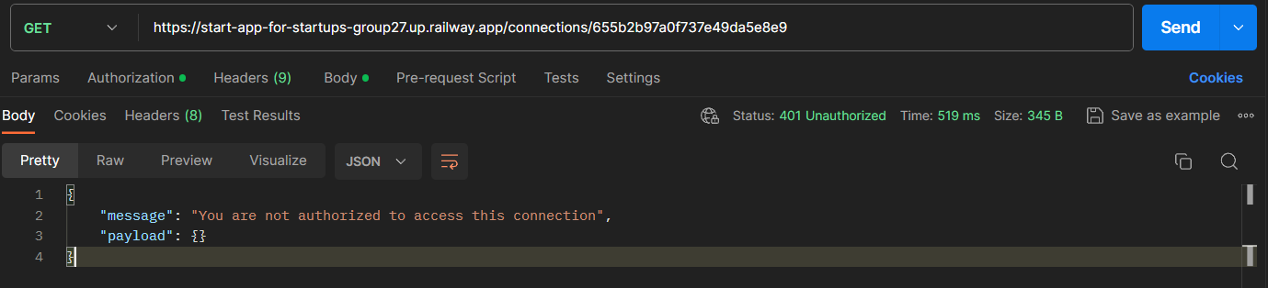

## Chat Privacy

Messages exchanged within the chat will remain accessible solely to the participants engaged in the conversation, upholding confidentiality and ensuring that the communication remains private between them.

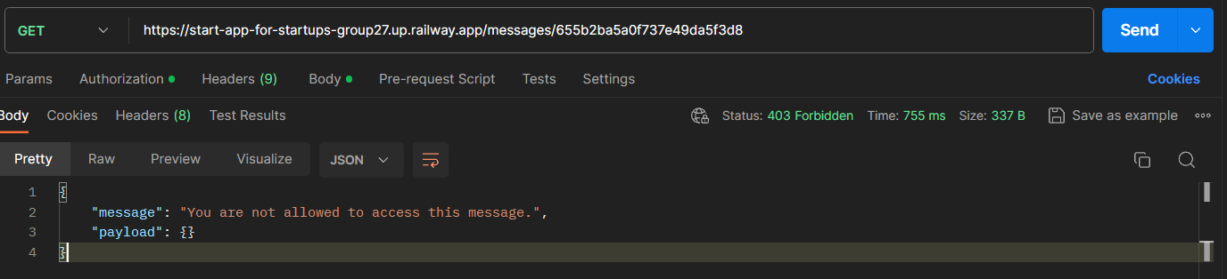

## Job Application Privacy

Only the individual submitting the job application and the organization that posted the job profile will have access to the application details, ensuring confidentiality and limiting visibility to authorized parties involved in the hiring process.

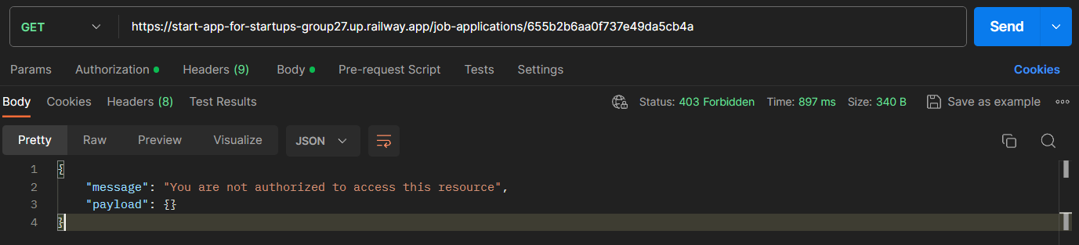

## Job Candidate List Privacy

The candidate list for a job profile remains exclusively accessible to the organization that posted the job, safeguarding the privacy of applicants and restricting visibility to only those authorized within the hiring entity.

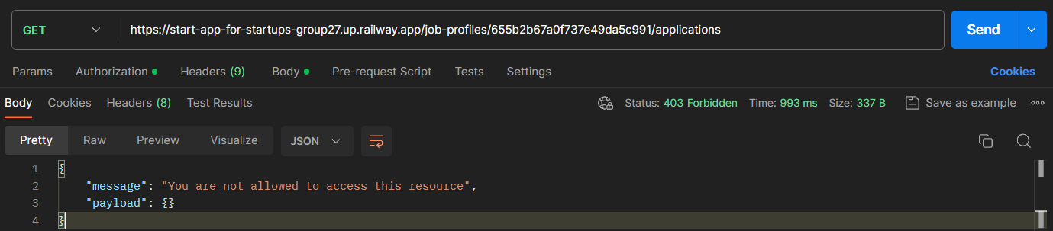

# Security:

* Passwords are encrypted using Node.js bcrypt module
* JWT system is used for authentication, JWT cookies will be stored for 24 hours. After that user will be required to log in again.
* All editable resources are protected by access middlewares to prevent unauthorized modifications or unauthorized access from unauthorized users.

Security report by <https://pentest-tools.com/> :



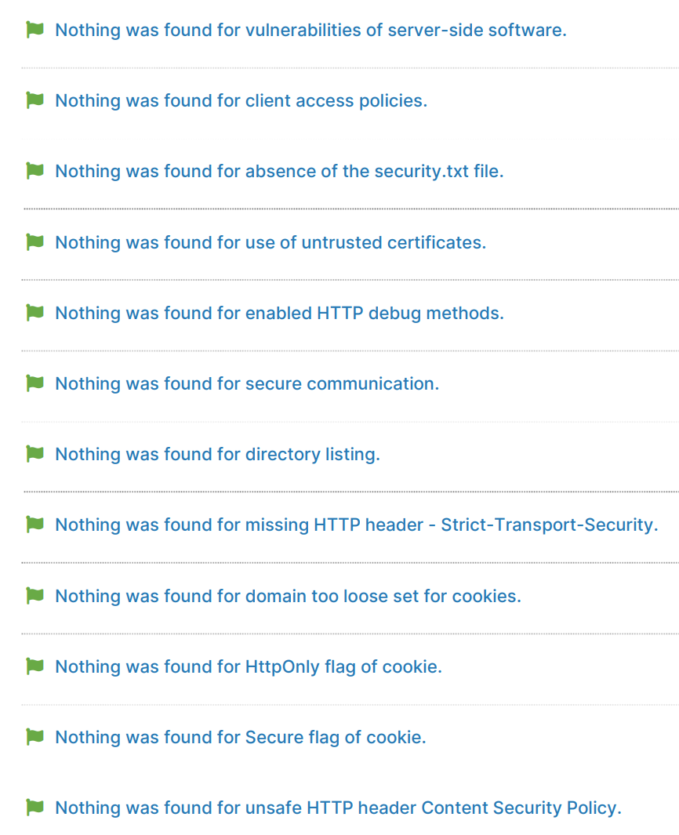

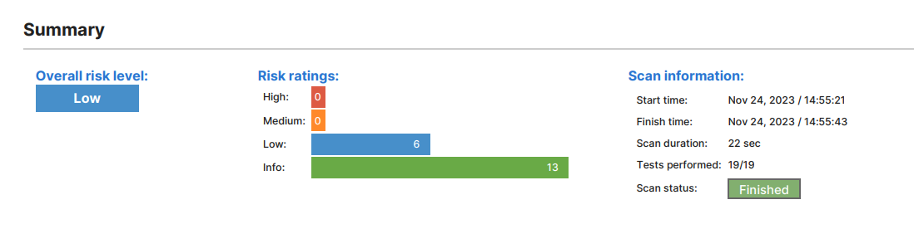

# Scalability:

Tested 250 clients per minute on a URL using [loader.io](http://loader.io) on https://start-app-for-startups-group27.up.railway.app/posts/ URL end-point

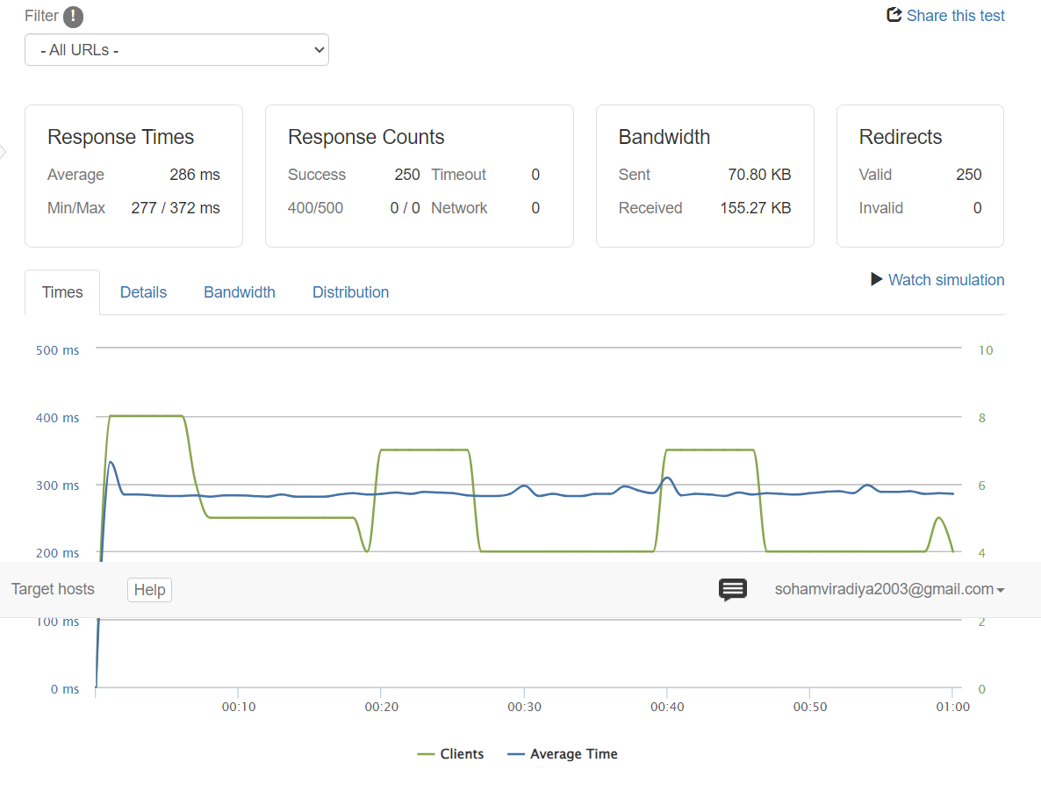

This site uses a CDN for delivering its files. A Content Delivery Network (CDN) distributes a website's files throughout the world, reducing request latency.

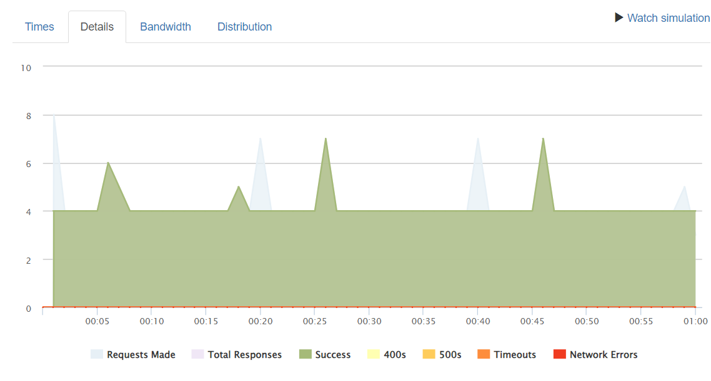

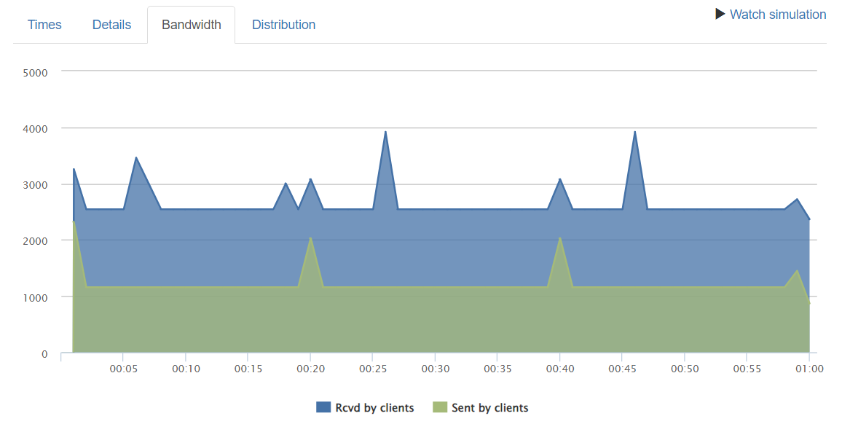

# Maintainability:

Both the Frontend and Backend repositories are meticulously organized and consistently maintained. The Frontend Repository adheres to React best practices, ensuring a structured and efficient codebase. Meanwhile, the Backend Repository demonstrates a well-thought-out architecture, dividing functionalities into independent modules like middleware, controllers, services, and schemas.

Moreover, this structured approach not only streamlines development but also simplifies the debugging process. With distinct modules, debugging becomes more precise, allowing for targeted identification and resolution of issues. Additionally, this architecture makes extending functionalities or adding new features more straightforward. The clear separation of concerns and modular design enables seamless integration of new components, fostering agility and facilitating the evolution of the application with minimal disruption to the existing codebase.

# Reliability:

## Database Reliability:

Our Mongodb Atlas server has replicated our database in 3 instances to reduce downtime.

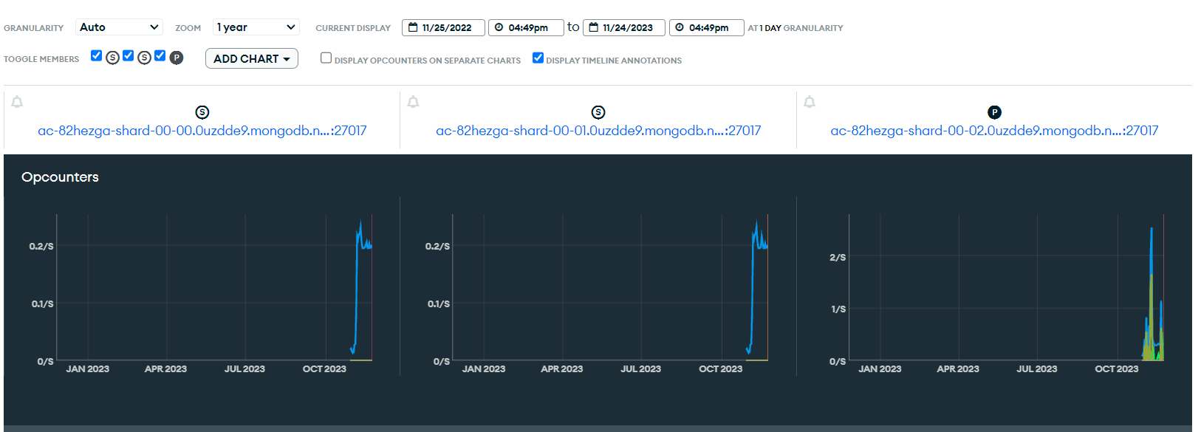

## Backend Server Reliability:

Our backend server has the capability to auto-restart upon crashing. This contributes significantly to system reliability and continuity. Furthermore it is capable of handling multiple requests at once in a non-blocking way.

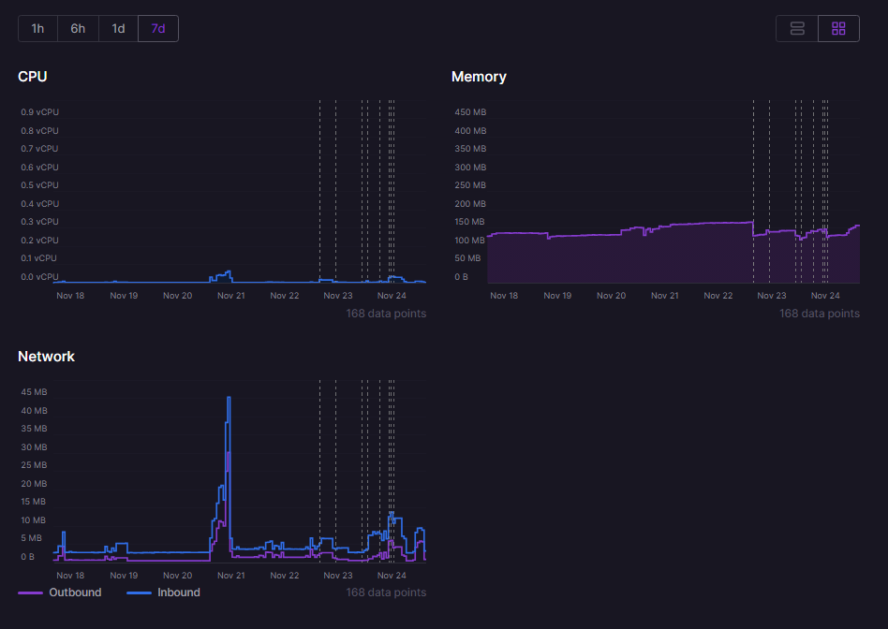

# Ease of Use:

Tested with: <https://www.webpagetest.org/>

## Lighthouse Report:

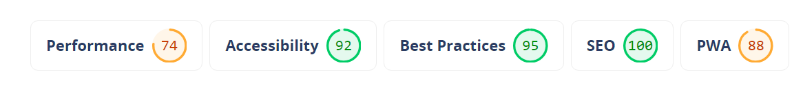

## Performance Report:

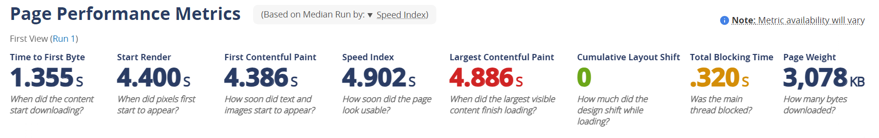

## Web Vitals Report:

## Best Practices:

# Portability:

The website underwent comprehensive testing across various screen resolutions and diverse browsers, ensuring optimal performance and compatibility across a wide spectrum of devices and user experiences.

## 



 

